Application Demo – Stock Management
Login Screen –
Valid Credentials –
Username – admin, Password – admin [Form Authentication]
While submitting , Httppost method is working here .
Take input from user go to database checks that the value is exist in the table or not through stored procedure.
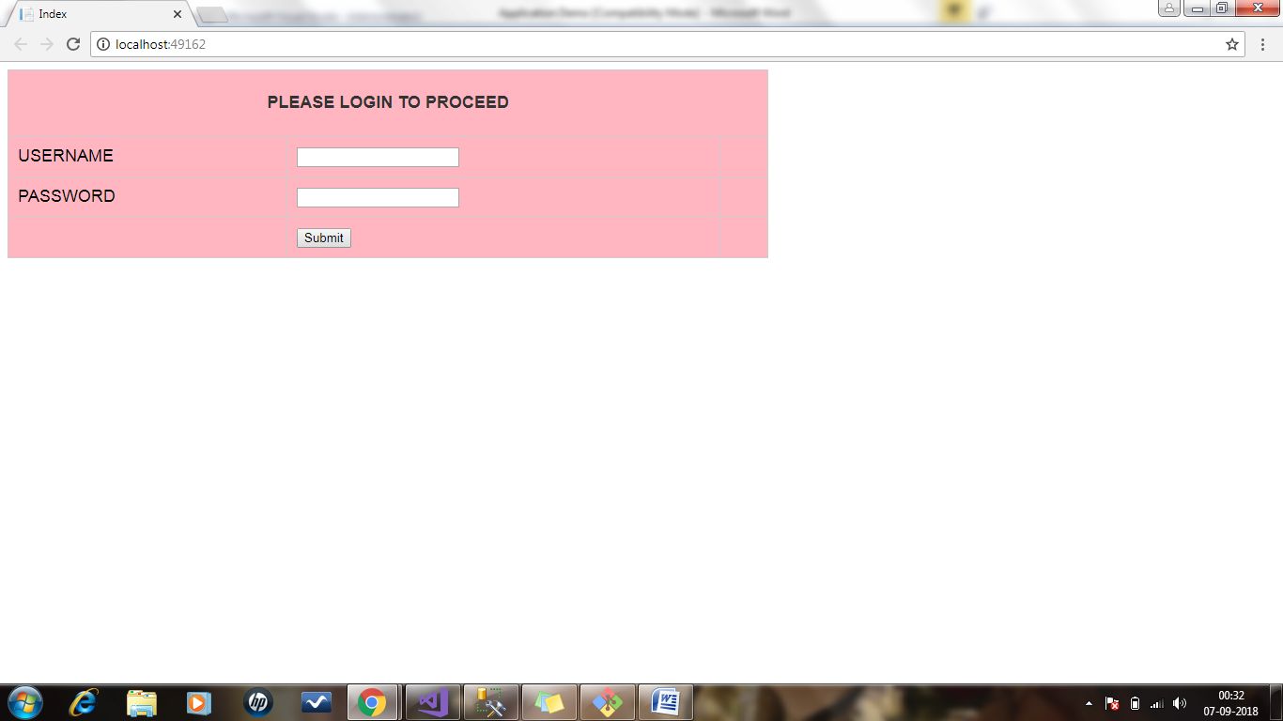
Required Attribute –
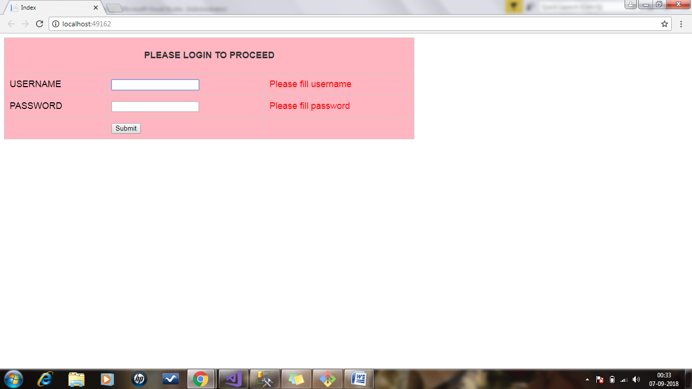

Provide Invalid Credentials redirect to “Invalid Credential View” page –
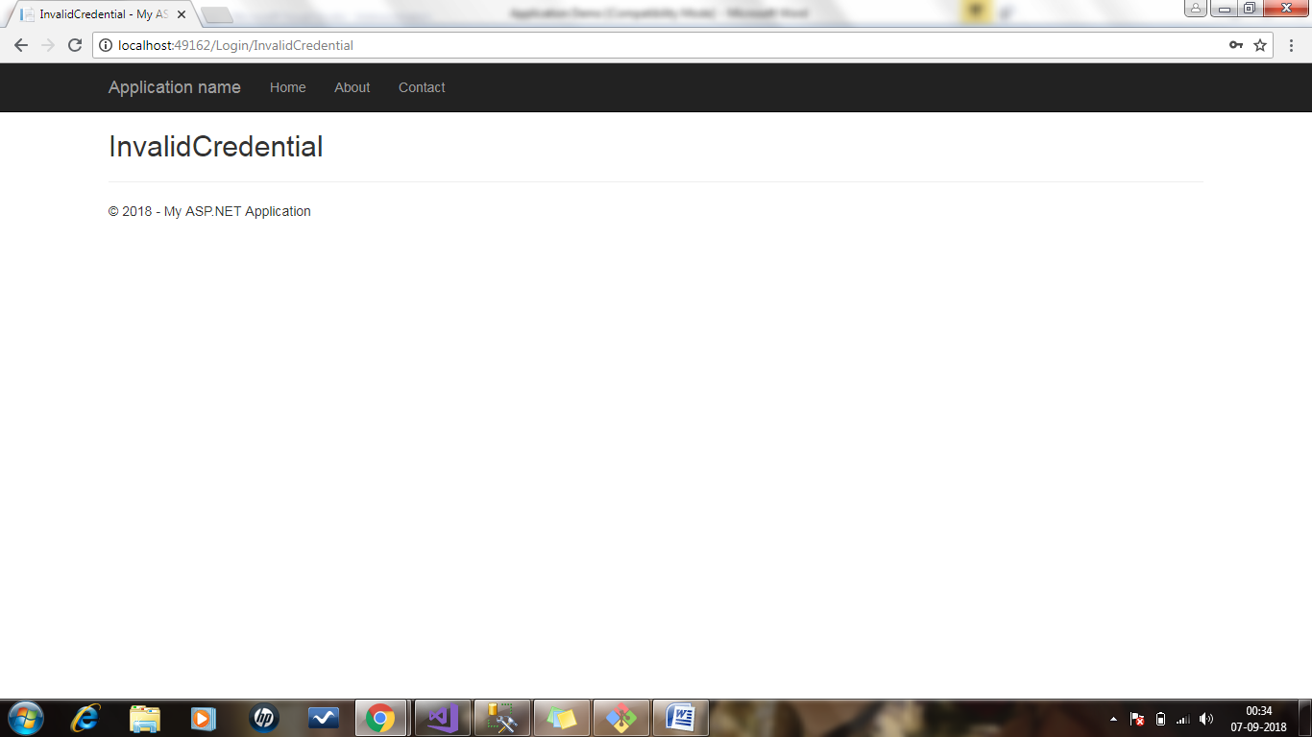

Provide valid credential , redirect to Welcome to admin panel page
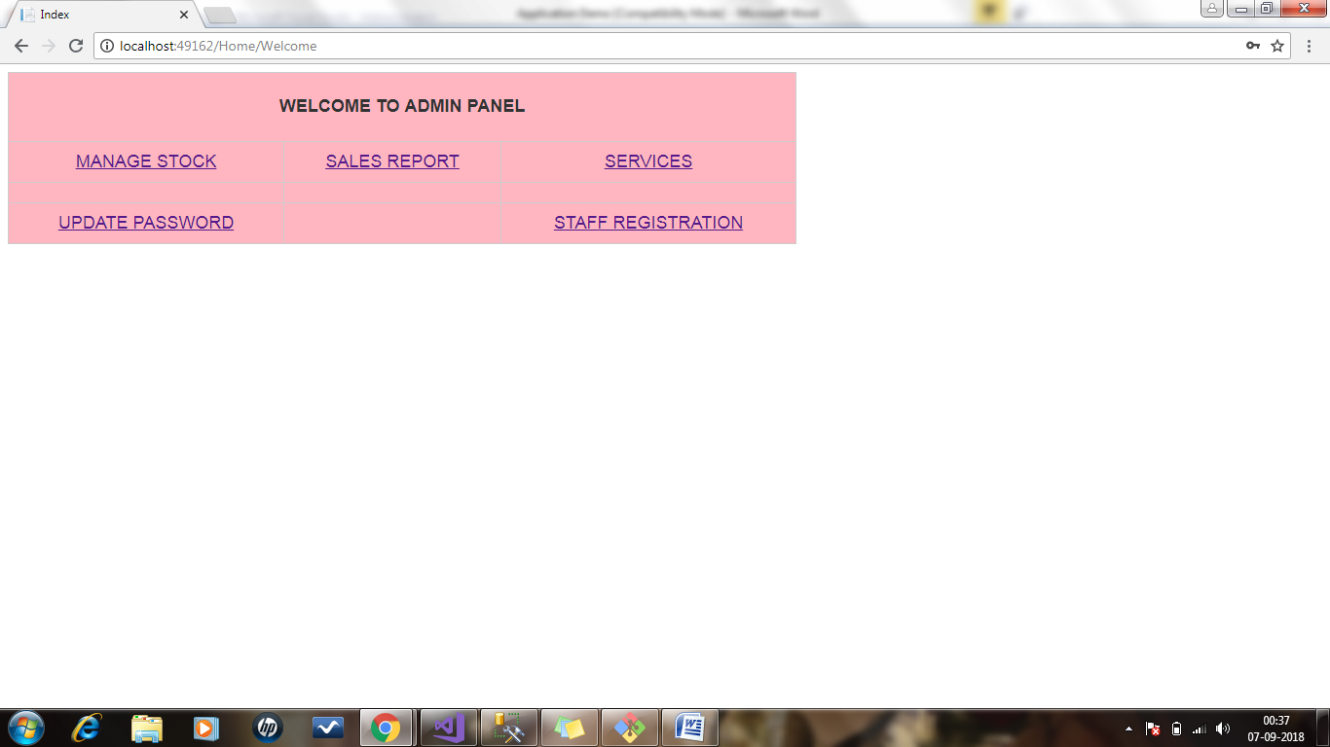

Manage Stock link(Html Action Link) is working fine as of now –
Layout has been used for four options -
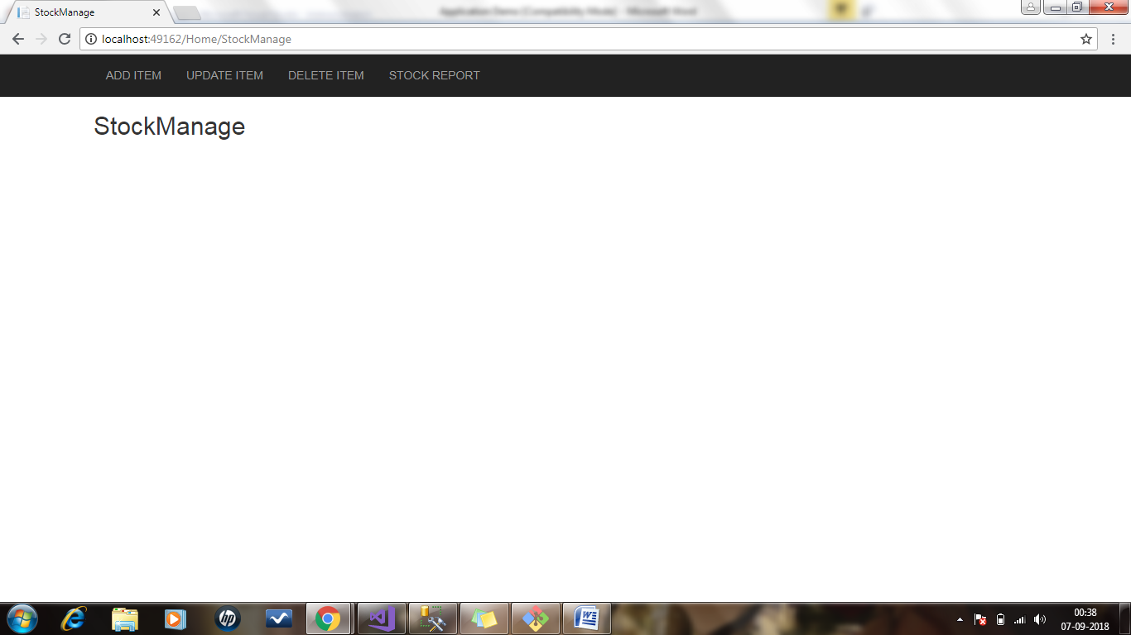

Only Add Item option is available –
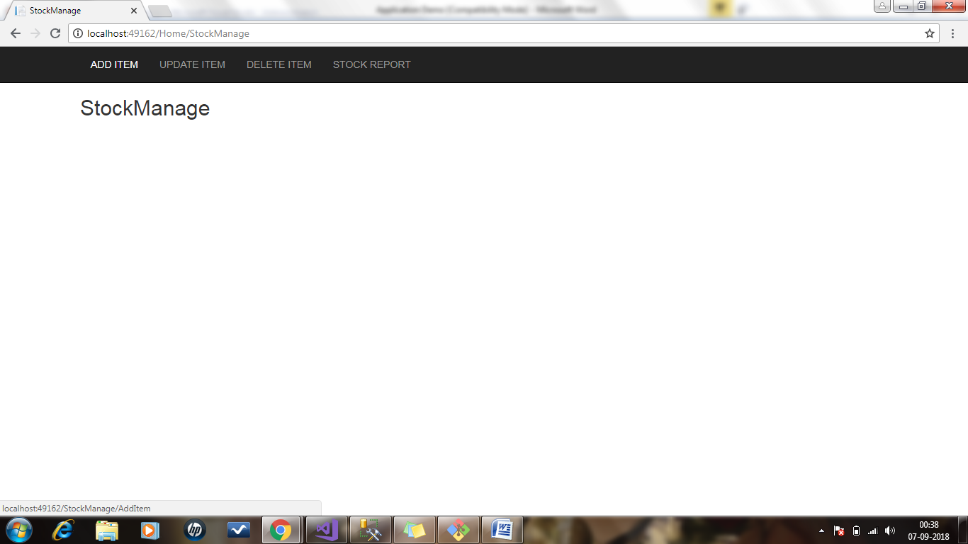

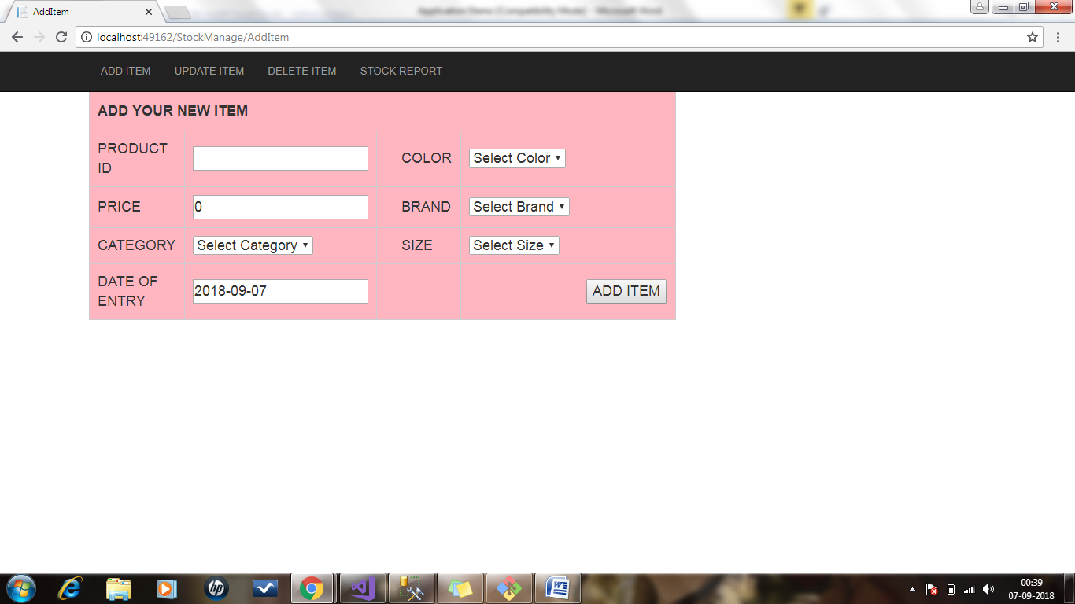
Dropdowns are populating the value from data base table using stored procedure, ID-Value pair has been generated.
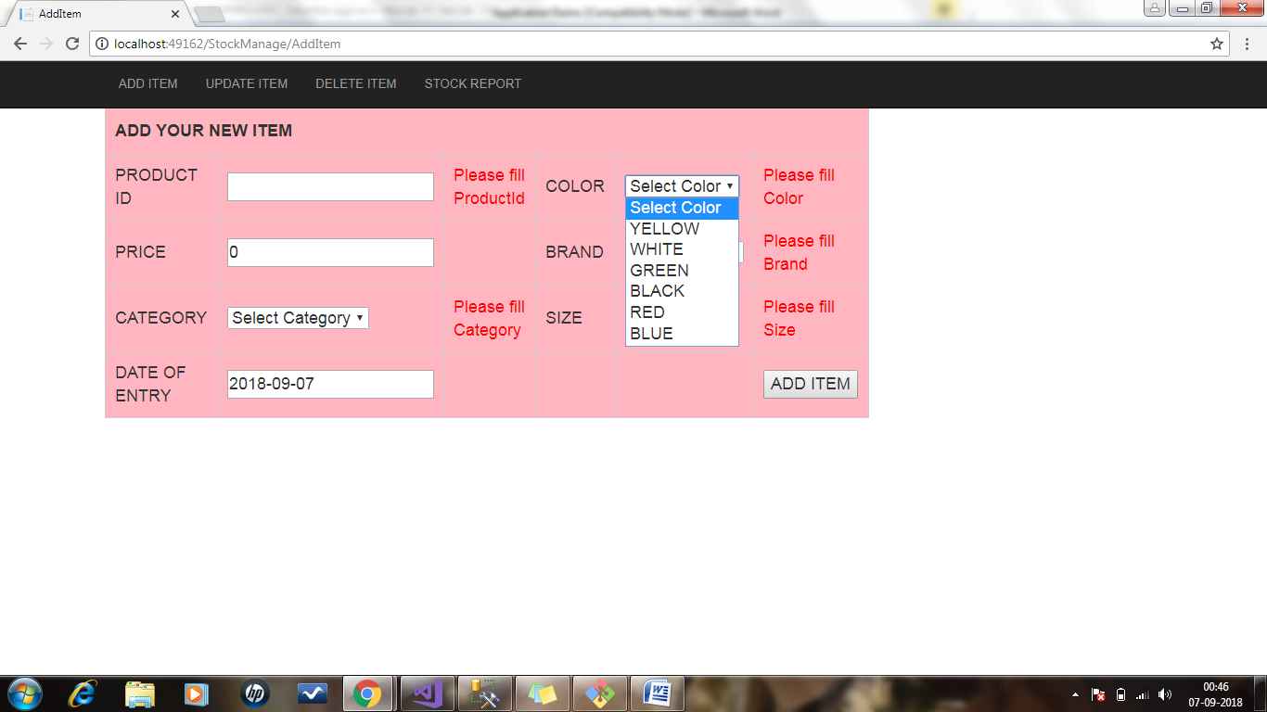
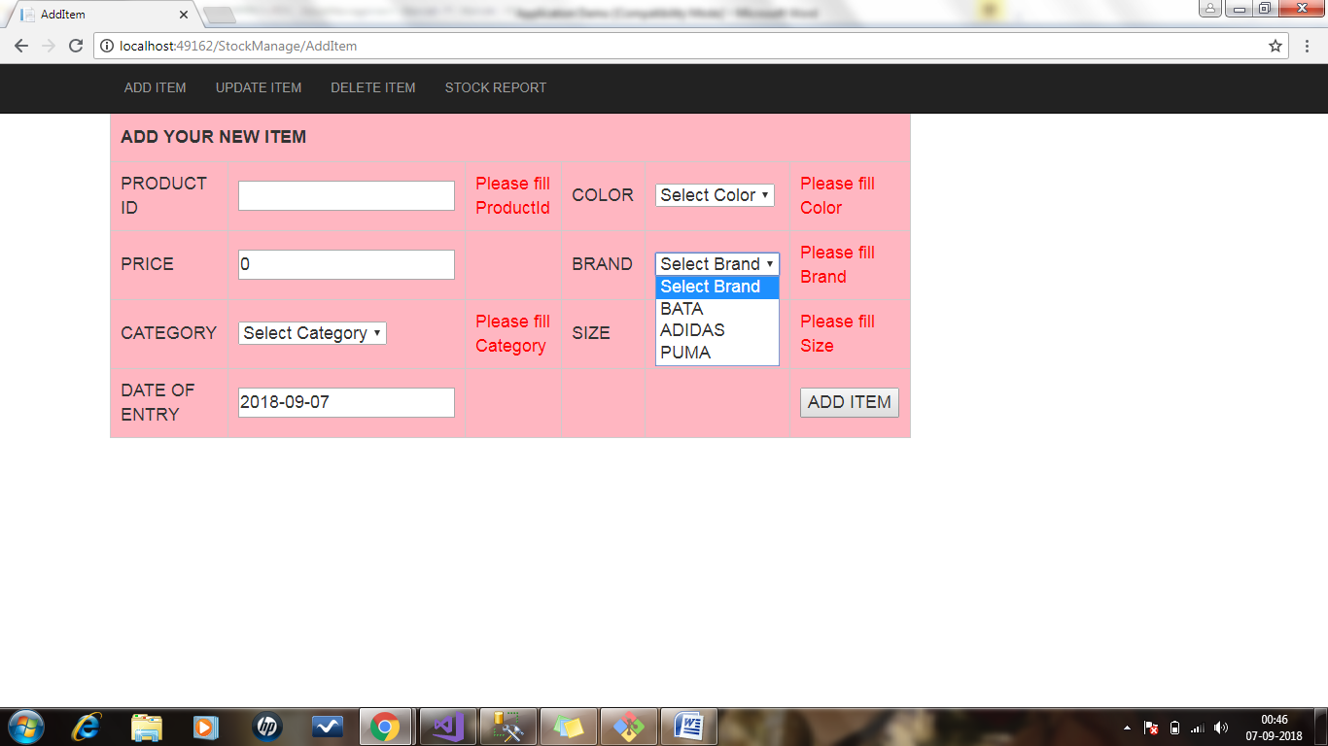

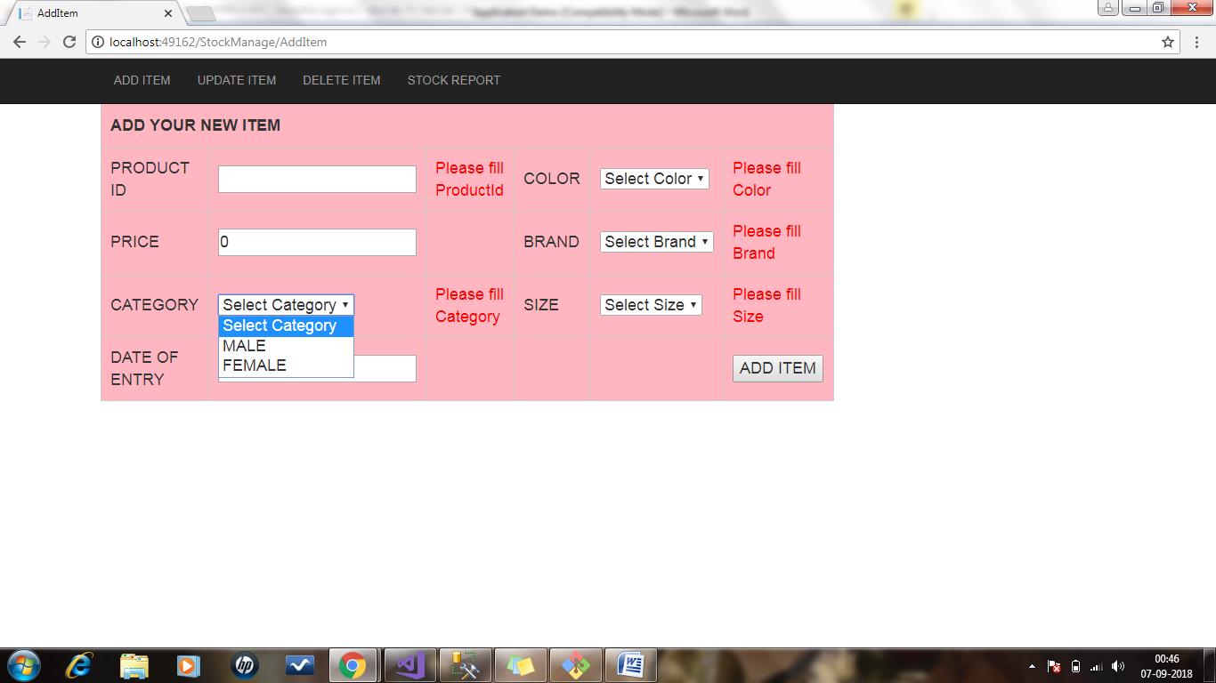

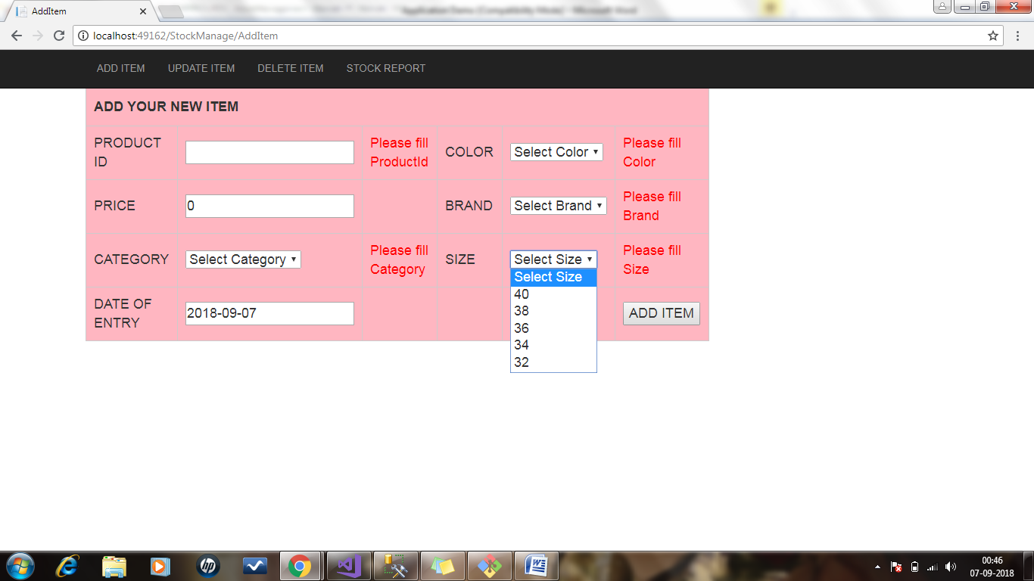

Required attribute –

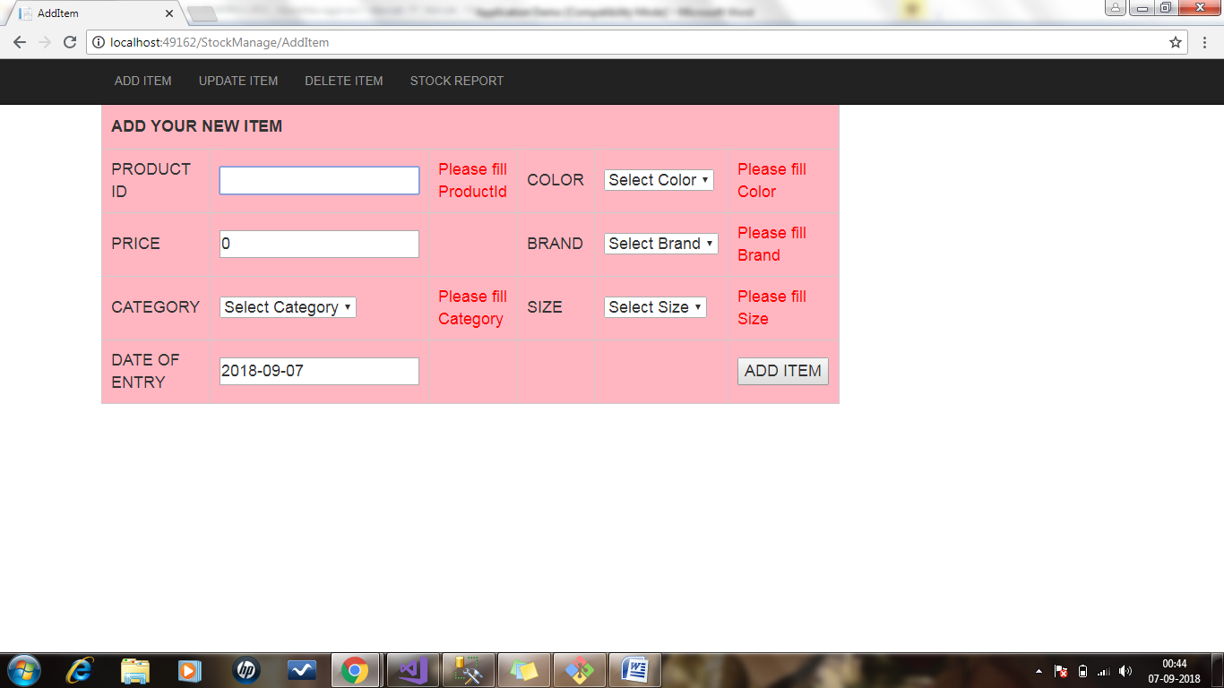

Date of Entry is system generated date –
All values have been filled –
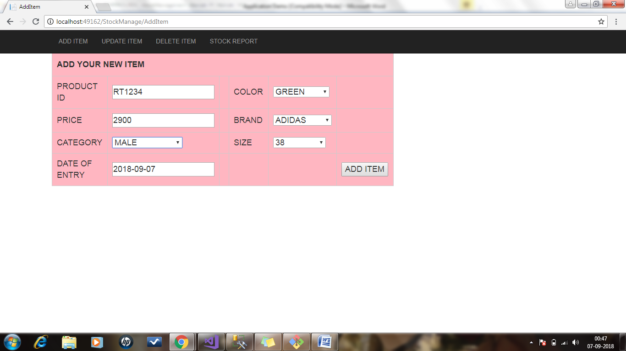

Now click on add item – redirect to item added successfully -
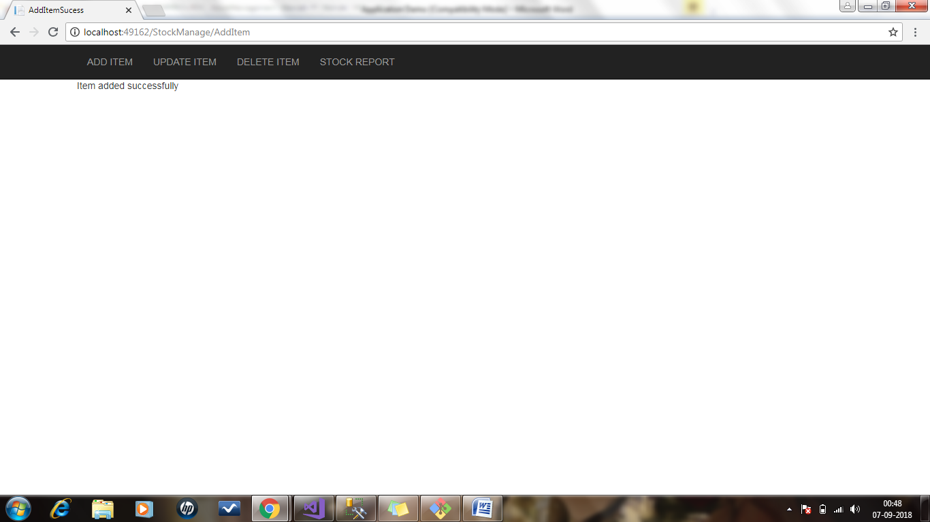

From Datebase –

